26th February 2024
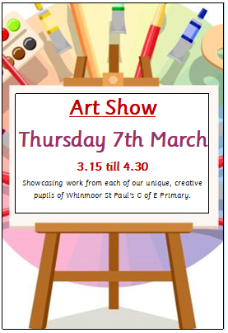

Dear Families,

We would like to invite you to an exhibition to showcase all of
our children’s artwork. Please come and support the children
at this absolutely stunning event which will be held in the
school hall.
All of the children’s artwork has been professionally framed,
so you can browse and view their masterpieces in their full
splendour. The children are very excited and proud of their
artwork and you will be amazed at the stunning displays.
The event will be open from 3.15pm on Friday 8th March,
showcasing the work that each child in school has completed
in their art lessons.

To raise money for the school, you can also buy your child’s
framed masterpiece at the exhibition at £5 each.
Proceeds will be spent on new art resources, for the children.

If you are unable to attend on the day, you can still purchase
your child’s framed picture by calling into the school office after
the exhibition, where the artwork will be available for a further
two weeks.

We hope you will enjoy and support this event and help raise funds for the school! We know you will find it hugely enjoyable and be amazed at the fantastic masterpieces on display and be very proud of your child’s achievement.
Yours sincerely,

Ms Reynolds
Art Lead.

